

CSA1109-Object Oriented Analysis and Design

CO-5 AT -1

Constraint-Based Problem Solving

Ashmi P S
192571004

1.Scenario: Online Banking System
Introduction
An online banking system handles highly sensitive financial data and operates under strict expectations of speed, security, and availability. Because the four core modules- Account Management, Fund Transfer, Bill Payment, and Transaction History - directly move and expose customer money and personal data, quality assurance (QA) must be applied rigorously against three binding constraints: every transaction must complete in under two seconds, every session must be protected by multi-factor authentication (MFA), and the system must reliably support 5000 or more concurrent users. This answer analyzes the system module by module, applies structured QA techniques, identifies the potential defects that threaten security, performance, and reliability, and proposes concrete testing strategies, justifying how each strategy safeguards overall system quality.
Techniques Applied
- Security Testing: Verifies authentication strength, MFA enforcement, session management, and protection of data in transit and at rest through encryption (TLS, AES).
- Performance and Load Testing: Measures response time, throughput, and resource utilization under simulated loads up to and beyond 5000 concurrent users to confirm the two-second transaction budget holds under stress.
- Reliability Testing: Assesses system uptime, fault tolerance, and recovery behaviour-including database failover and transaction rollback - to confirm the system behaves correctly during and after failures.
- Functional and Regression Testing: Confirms each module (account, transfer, bill payment, history) behaves correctly per specification and that new releases do not break existing functionality.
- Penetration Testing: Simulates real attacker behaviour (SQL injection, session hijacking, brute-force login) to expose exploitable vulnerabilities before deployment.
- Static and Dynamic Code Analysis: Scans source code for insecure patterns (hardcoded credentials, weak cryptography) and monitors the running application for anomalous behaviour.
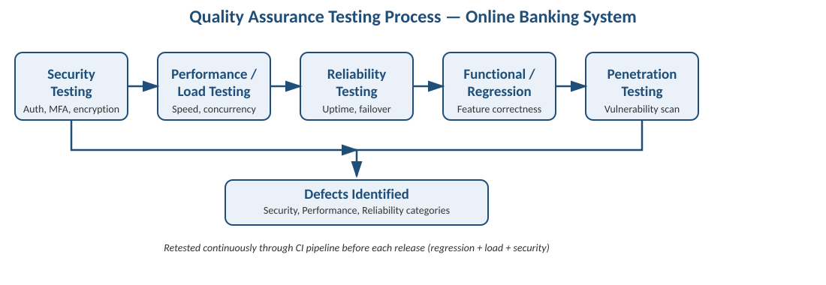

Potential Defects Identified
1. Security Defects
- MFA bypass: a defect that allows login to succeed after only the password step, for example if the OTP verification endpoint is reachable without validating the first factor's session token.
- Session fixation or hijacking: predictable or non-expiring session identifiers allow an attacker to reuse a valid session, especially over unsecured networks.
- Inadequate encryption: sensitive fields (account numbers, OTPs) transmitted or stored without proper TLS/AES protection, exposing data to interception or database leaks.
- Broken access control: a user able to view or transact on another customer's account by manipulating an account ID or API parameter (an authorization defect, not authentication).
- Weak brute-force protection: no lockout or rate-limiting on login or OTP attempts, allowing automated credential-guessing attacks.
2. Performance Defects
- Transaction latency exceeding two seconds under concurrent load, caused by unoptimized database queries, lack of connection pooling, or insufficient caching.
- Thread or connection pool exhaustion at high concurrency, causing requests to queue or fail once the 5000-user threshold is approached.
- Memory leaks or unbounded resource growth during sustained load that degrade response time progressively rather than failing immediately, making the defect harder to detect in short tests.
- Inefficient third-party integration calls (payment gateway, SMS/OTP provider) that become the bottleneck during peak concurrent usage.
3. Reliability Defects
- Duplicate or lost transactions when a network timeout occurs mid-transfer and the client retries without an idempotency check, risking a double debit or a debit with no corresponding credit.
- Inconsistent state after partial failure: a fund transfer that debits the sender but fails to credit the receiver because the operation is not wrapped in a proper atomic transaction.
- Insufficient failover: a single point of failure in the database or authentication service that causes total downtime instead of graceful degradation.
- Incorrect scheduled bill payments: a defect in the job scheduler that causes a bill to be paid twice, paid late, or silently skipped.
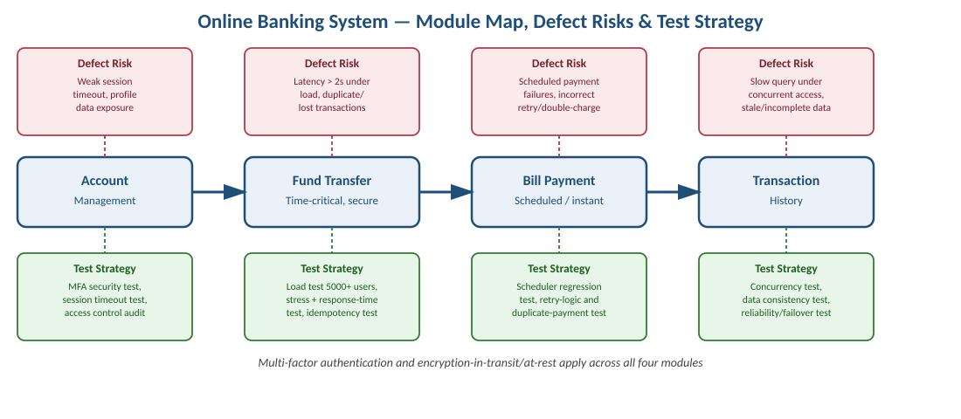
Proposed Testing Strategies and Justification
The table below maps each defect category to specific testing strategies and explains how each strategy protects the corresponding constraint.
Defect Category | Testing Strategy | Constraint Protected
Security | MFA enforcement testing, penetration testing, session-management testing, and static code analysis for hardcoded secrets and weak cryptography | Multi-factor authentication required
Security (Access Control) | Authorization/role-based access testing using both valid and manipulated account IDs to confirm horizontal privilege boundaries hold | Data confidentiality, MFA
Performance | Load testing at 5000, 7500, and 10000 simulated users; stress testing beyond capacity; soak testing over several hours to catch memory leaks | Transaction time < 2 seconds, 5000+ concurrent users
Performance (Bottlenecks) | Component-level profiling of database queries and third-party API calls; caching and connection-pool tuning validated through repeat load tests | Transaction time < 2 seconds
Reliability | Idempotency testing (duplicate request simulation), atomic-transaction testing (kill process mid-transfer and verify rollback), and failover/chaos testing on the database layer | 5000+ concurrent users, data integrity
Reliability (Scheduler) | Regression testing of the bill-payment scheduler across time-zone and retry edge cases, with automated checks for duplicate or skipped payments | Reliability, data integrity

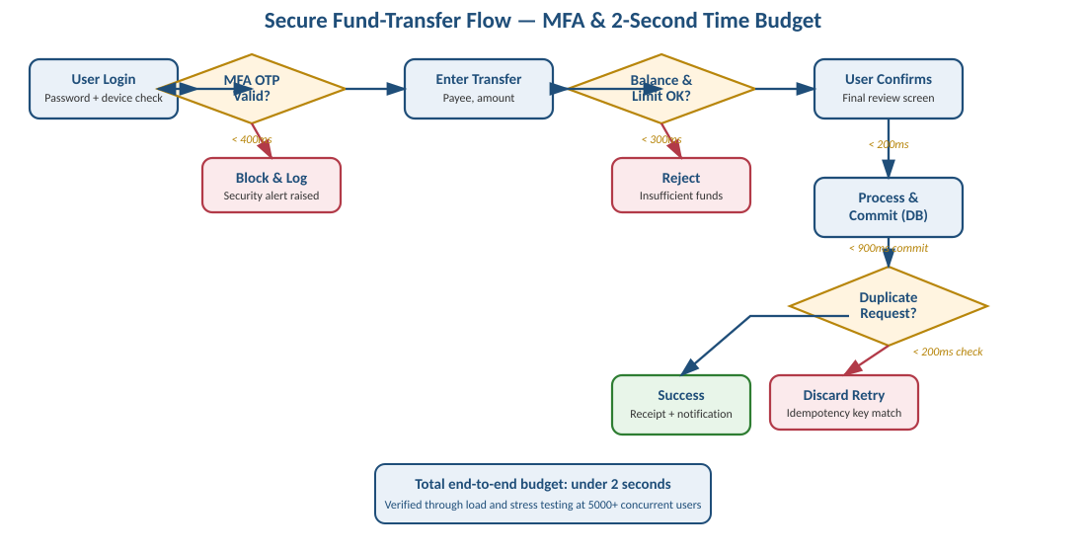
How the Strategies Ensure System Quality
- Security testing directly enforces the MFA constraint by verifying that no transaction path can bypass the second authentication factor, and penetration testing catches exploitable gaps before attackers do.
- Load and stress testing validate the 5000+ concurrent user constraint empirically rather than by assumption, revealing the exact point at which response time would breach the two-second budget so capacity can be provisioned ahead of it.
- Idempotency and atomic-transaction testing directly address the most damaging reliability defect in banking - a transaction that debits without crediting - by proving the system either completes a transfer fully or not at all.
- Chaos and failover testing confirm that a single component failure degrades gracefully rather than causing full downtime, protecting the 24/7 expectation implicit in a banking service.
- Combining these strategies in a continuous integration pipeline (functional and security tests on every commit, load tests before every release) ensures defects are caught early, when they are cheapest to fix, rather than in production where they risk financial loss and regulatory exposure.
Conclusion
The Online Banking System's Account Management, Fund Transfer, Bill Payment, and Transaction History modules each carry distinct security, performance, and reliability risks, from MFA bypass and broken access control to transaction latency and duplicate-payment defects. Applying security testing, load and stress testing, reliability and idempotency testing, and continuous regression testing directly targets these risks and ties each testing strategy back to one of the three given constraints - sub-two-second transactions, mandatory MFA, and support for 5000 or more concurrent users. Together, this structured QA approach gives measurable assurance that the system is secure, fast, and dependable enough for real financial use.

